Chapter XIII

Interfaces and Abstract Classes

Chapter XIII Topics

13.1 Introduction
13.2 Interfaces
13.3 Implementing Interfaces
13.4 Implementing Multiple Interfaces
13.5 Using Fields in an Interface
13.6 Abstract Classes
13.7 Abstract Classes as a Bridge Class
13.8 Abstract Classes as an Adapter Class
13.9 Constructors in an Abstract Class
13.10 Behind the Generics Curtain
13.11 The Generics List Interface
13.12 Generics and Subinterfaces
13.13 Summary

13.1 Introduction

Java has four Collection classes, ArrayList, LinkedList, HashSet and TreeSet. You have already learned about the ArrayList class in an earlier chapter. Figure 13.1 shows a diagram that demonstrates the relationship of these four classes in Java. It is normal to think that Collection is a super class and both List and Set are subclasses that extend Collection. At one more level down the inheritance tree you then find four more subclasses, ArrayList, LinkedList, HashSet and TreeSet. This seems quite logical, but Collection, List and Set are all three called an interface and not a class.

Figure 13.1
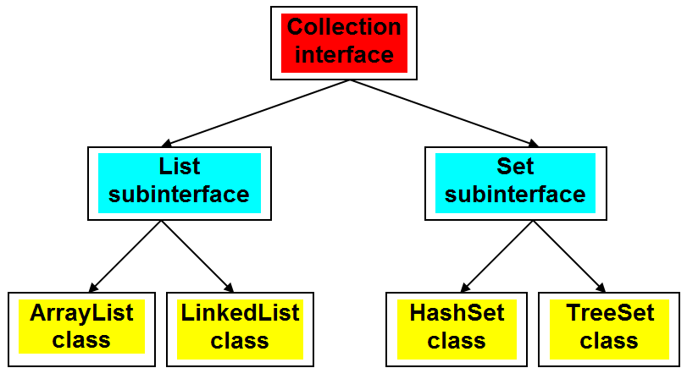

Let us start at the top with the Collection interface. What is a collection? It is a very general data structure, defined below. This is a good start. You know little about collections, but you do know that a collection is not a simple data type that stores a single value. A collection implies that more than one data value can be stored. It is a data structure, and it does not provide much information.

Collection
A collection is a group of objects.

Suppose that you want to discuss the methods of a Collection class. You can discuss methods without any concern about how a method is implemented. This is no different from building a house. You can talk about the design of the house, the size, the number of rooms and many other details without mentioning how any of these house details will be constructed. This is the stage where you sit down with an architect. Later the architect sits down with a building contractor to make your house a reality.

A very practical method for a Collection class is add, used to add data to a Collection object. We also realize that a collection is such a general data structure that it is really is not very practical. Yet, it is possible to say that an add method makes sense. Now we travel one level down from Collection and become a little more specific with List and Set, whose definitions follow.

Lists
A List is a linear collection that allows access to any element in the list. A List may have duplicate elements.

Sets
A set is an unordered collection without any duplicate elements.

The definitions of a list and a set bring up an interesting point. A list may have duplicate elements. One example of a list data structure is an array and you know that arrays may have duplicate elements. On the other hand, a set may not have duplicate elements. Now we do want to add new elements to either a List object or a Set object, but this addition cannot happen in the same manner. An add method for a List object checks to see if there is enough memory available. It may check if the proper data is added to the object, but it is unconcerned about any duplication. There exists a different story with an add method for a Set object, which performs many of the same checks as a List add method. However, an additional check must be performed to insure that the new data is not already stored in the object.

The conclusion then is the following. Start with a structure that resembles a class, which has no concerns with method implementations. Call such a structure an interface. In the Collection interface it is possible to have a lovely discussion about what type of methods should be included in a collection data structure. Since we are at the "abstract" level, implementations are not included.

It makes sense not to implement at this higher level. You just saw that lists and sets add new elements in a different manner. Yes, both lists and sets add new elements, but they cannot use the same exact group of program statements. The solution then is to provide program headings only. In the case of the Collection interface the actual implementations of the methods occur at the level of the ArrayList, LinkedList, HashSet and TreeSet classes. You have already used the ArrayList class. The other three Collection classes are only used as an illustration. Details about those classes will be explained in a future course.

13.2 Interfaces

What does interface mean? With computers it is a common term. A printer, connected with a cable to a computer requires an interface. This also needs to be a specific kind. At the time when this chapter was written printers usually have an USB Interface Cable, shown in figure 13.2.

Figure 13.2
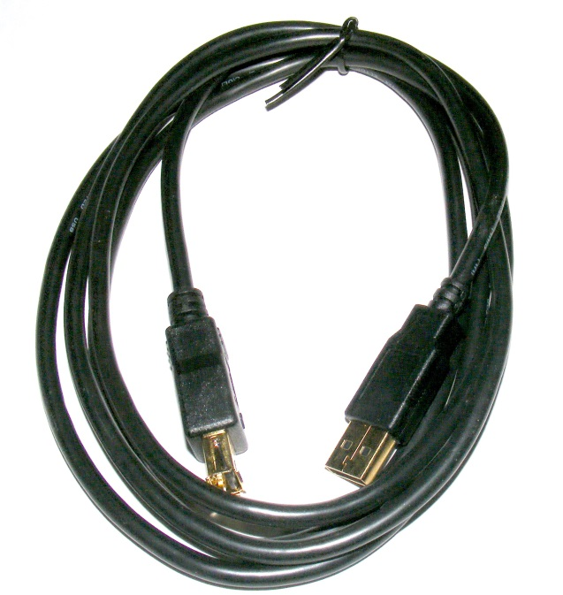
So interface implies communication, as between a computer and a printer. It can also be between people. Imagine that a bank administrator requires new computer software. This bank administrator is a bank executive, not a software engineer. There is a meeting now and in the room are various bank employees and several representatives from a software company.

It is possible for the bankers to specify what they want for their software. They will not be speaking programming terms or even programming languages. They will speak using abstraction. This is a very practical tool. Bankers know very little about software engineering and software engineers know very little about banking. Yet they can communicate.

Consider the following: May 25, 1961 President Kennedy makes his very important speech that before the decade ends we will put a man on the moon and bring him back alive. What is remarkable is the fact that John Glenn did not become the first American to orbit the Earth until February 20, 1962. How can President Kennedy discus going to the Moon? In a word . . . Abstraction. This abstraction concept is all around us, and yes, July 20, 1969 Neil Armstrong was the first man to walk on the Moon. In programming, abstraction is a very important tool and the primary focus of this chapter.

Abstraction
The concept of communicating about ideas without concern about the implementation of the ideas.

Figure 13.3 shows an example of a Java interface. You find BankA.java in folder Interface01. There are similarities with a class, but also some big differences. Sure there is the reserved word interface in place of class, but look at the methods. None of the methods have a body. Nothing... and they end with a semi-colon. Right now this does not look very practical and that is precisely the point.

Figure 13.3
// Interface01A
// This program introduces the abstract <Bank> interface.
// All interface methods are abstract and have no method bodies.
public interface BankA
{
public double getBalance();
public void makeDeposit(double amount);
public void makeWithdrawal(double amount);
}

This interface is precisely what a banker understands. Create me some software that gives the bank and its customers a balance, makes a deposit and makes a withdrawal. How the programmers achieve this is of no concern.

You will find as we move along on this computer science journey that an interface can do more than allow communication about a concept without concern about implementation, but for now this is where we start.

Now what can we do with an interface? How about compiling it? The interface, BankA, just like a class, is placed in a file, called BankA.java. Like a class, figure 13.4 shows that it compiles very nicely. A further attempt to run the program causes problems. Figure 13.5 shows that Java is not happy. This may be a nice interface, but it does not have a main method or applet to execute a sequence of Java commands. The particular response is unique to the jGrasp IDE, but regardless of what you use, executing an interface won't work.

Figure 13.4
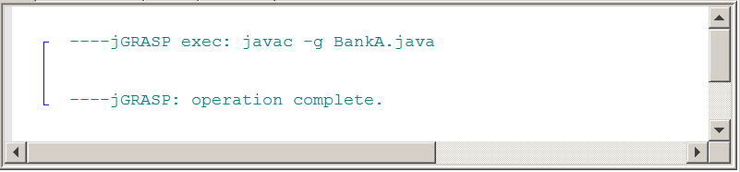

Figure 13.5
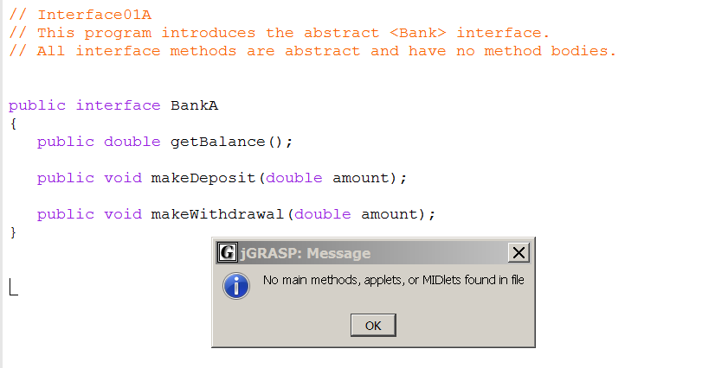

An interface is abstract and all its methods are abstract. This point is shown in figure 13.6 where you see the BankB interface. It really is the same interface as BankA, but now the optional abstract keywords are inserted.

Figure 13.6
// Interface01B
// The reserved word abstract is optional.
// In an interface abstract is implied if not used.
public abstract interface BankB
{
public abstract double getBalance();
public abstract void makeDeposit(double amount);
public abstract void makeWithdrawal(double amount);
}

Java Interface
A Java Interface provides a group of method signatures that will be available for any client of a class that implements the interface. Implementation details of the Interface methods are neither required nor desired at the Interface level.

13.3 Implementing Interfaces

The first sequence of programs, that follows, involves a simple Bank program that will process common bank procedures like making deposits, making withdrawals and checking the bank account balance. Switch to the Interface02 folder. Three separate files are properly stored there. Frequently all necessary classes are placed in one file for convenience of viewing the details. Proper program design does prefer each class, or interface, to be placed inside its own file. Hence the separate folders to keep everything organized.
We now come to the second part of the interface business. An interface by itself does nothing. You cannot instantiate an interface and all the methods lack information necessary for execution. The Bank.java interface you can look at, but it is the same file you have seen earlier. Right now look at the CreditUnion.java file, in figure 13.7. You will see each one of the Bank interface methods, complete with a method body. You also see the attribute balance and a constructor CreditUnion.

Figure 13.7
// The <CreditUnion> class implements the <Bank> interface.
public class CreditUnion implements Bank
{
private double balance;
public CreditUnion(double c)
{
balance = c;
}
public double getBalance()
{
return balance;
}
public void makeDeposit(double amount)
{
balance += amount;
}
public void makeWithdrawal(double amount)
{
balance -= amount;
}
}

Now switch to Runner02.java, in figure 13.8 and observe the program output. A tom object opens a new CreditUnion account. Note that the CreditUnion constructor is new to the implementing class. Interfaces have no constructors. The testing program makes a deposit, makes a withdrawal and prints the balance after each transaction.

There are three files involved. There is an original Bank.java interface, followed by the implementing CreditUnion.java class and then the Runner02.java class to execute and to test the complete program.

The execution output of Runner02 is shown in figure 13.9. Everything is in order. The new tom object opens an account with $5000, makes a $1500 deposit to increase the balance to $6500, and then withdraws $2500 ending with $4000.

Figure 13.8
// Interface02
// The <Runner02> class tests the implementation of the
// <CreditUnion> class and the <Bank> interface.
public class Runner02
{
public static void main (String[ ] args)
{
CreditUnion tom = new CreditUnion(5000.0);
System.out.println("Tom's balance: " + tom.getBalance());
tom.makeDeposit(1500.0);
System.out.println("Tom's balance: " + tom.getBalance());
tom.makeWithdrawal(2500.0);
System.out.println("Tom's balance: " + tom.getBalance());
}
}

Figure 13.9
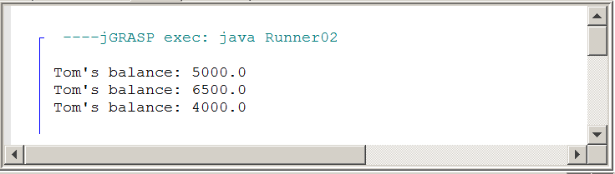

Using implements
First there is an abstract interface, like Bank.

Then comes a concrete class, which implements the interface.

The implementing class uses a different identifier name than the interface Bank name. This is required; otherwise you get a duplicate identifier error.

Are there special implementation requirements? For instance, what happens if you decide to implement some of the interface methods, but not all of them? The program in Interface03 addresses that concern. Folder Interface03 seems to show the same three files as the previous set. Take a look at CreditUnion.java, in figure 13.10. Do you see the difference?

Figure 13.10
// Interface03
// This <CreditUnion> class partially implements the <Bank> interface.
public class CreditUnion implements Bank
{
private double balance;
public CreditUnion(double c)
{
balance = c;
}
public double getBalance()
{
return balance;
}
public void makeDeposit(double amount)
{
balance += amount;
}
}

The CreditUnion class only partially implements the Bank interface. This is not allowed. Java already objects at the compile stage and makes it clear that not all of the abstract methods were implemented. Java uses the term override.

Figure 13.11
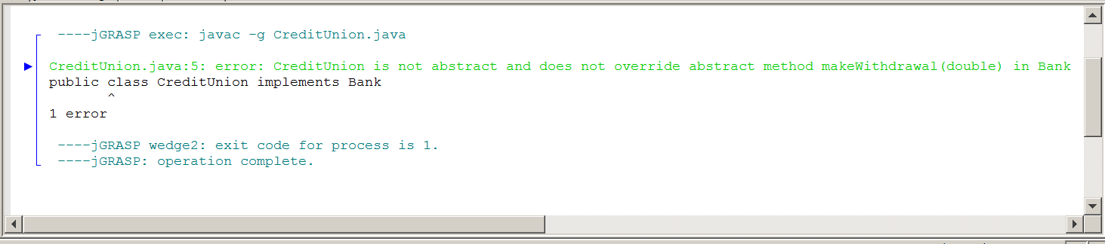
Implementation Rule
A class, which implements an interface, must implement every method declared in the interface.

Now consider going in the opposite implementation direction. Java does not allow an implementation that only partially implements the abstract methods in an interface. Will it allow additional method declarations? In other words, after you have implemented all the abstract methods, can you then continue and implement more methods that were never mentioned in the interface?

Switch to the Interface04 folder and look at the CreditUnion class in figure 13.12, which now adds method getAccount. The additional methods cause no problems. The program compiles and executes correctly.

Figure 13.12
// Interface04
// This <CreditUnion> class defines the <getAccount> method,
// which was not an abstract method of the <Bank> interface.
// A concrete class may implement more methods, but never less
// methods than are declared in the interface.
public class CreditUnion implements Bank
{
private int account;
private double balance;
public CreditUnion(int a, double c)
{
account = a;
balance = c;
}
public int getAccount()
{ return account; }
public double getBalance()
{ return balance; }
public void makeDeposit(double amount)
{ balance += amount; }
public void makeWithdrawal(double amount)
{ balance -= amount; }
}
A quick check with the runner program in figure 13.13, confirms that Java can handle this without difficulty.

Figure 13.13
// Interface04
// This program tests the <CreditUnion> class defining more methods
// than are declared in the <Bank> interface.
public class Runner04
{
public static void main (String[ ] args)
{
CreditUnion tom = new CreditUnion(736829056,5000.0);
System.out.println("Tom's account: " + tom.getAccount());
System.out.println("Tom's balance: " + tom.getBalance());
}
}

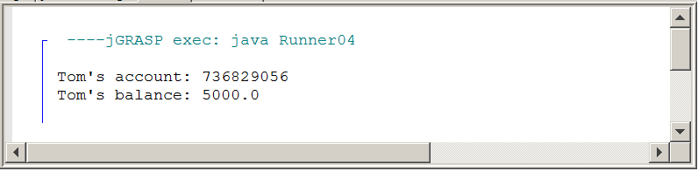

13.4 Implementing Multiple Interfaces

Consider the situation with a Checking interface, meant for handlings checking accounts and a similar Savings interface, meant for handling saving accounts exists. It is possible to create one class, called Bank, which implements both of the interfaces. Implementing multiple interfaces is demonstrated in folder Interface05. Start by looking at the Checking interface and the Savings interface first, in figure 13.14. There are no big surprises there. Each interface has three identical methods, a set for checking and a similar set for savings.
Figure 13.14
// Interface05
public abstract interface Checking
{
public abstract double getChecking();
public abstract void checkingDeposit(double amount);
public abstract void checkingWithdrawal(double amount);
}
public abstract interface Savings
{
public abstract double getSavings();
public abstract void savingsDeposit(double amount);
public abstract void savingsWithdrawal(double amount);
}

Figure 13.15 shows the secret to implementing multiple interfaces is the comma. The class heading shows the syntax. After that it is a matter of writing methods.

Figure 13.15
// Interface05
// This program shows how one class, <Bank> can implement two
// interfaces <Checking> and <Savings>.
public class Bank implements Checking, Savings
{
private double checking;
private double savings;
public Bank(double c, double s)
{
checking = c;
savings = s;
}
public double getChecking()
{ return checking; }
public void checkingDeposit(double amount)
{ checking += amount; }
public void checkingWithdrawal(double amount)
{ checking -= amount; }
public double getSavings()
{ return savings; }
public void savingsDeposit(double amount)
{ savings += amount; }
public void savingsWithdrawal(double amount)
{ savings -= amount; }
}

The runner program in figure 13.16 is rather brief. It is just a quick check that each interface is implemented and that one Bank object is now handling the methods for both interfaces.

Figure 13.16
// Interface05
// <Runner05> tests the <Bank> class implementing
// the <Checking> interface and the <Savings> interface.
public class Runner05
{
public static void main (String[ ] args)
{
Bank tom = new Bank(5000.0,7500.0);
System.out.println("Tom's checking balance: " + tom.getChecking());
System.out.println("Tom's savings balance: " + tom.getSavings());
}
}

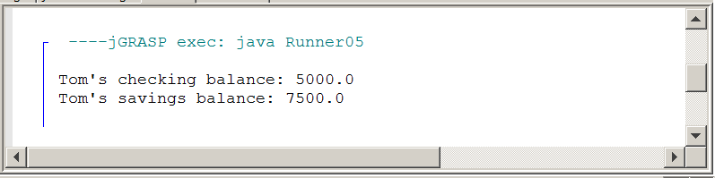

13.5 Using Fields in an Interface

It is possible that you think only methods are allowed in an interface. That is almost true. It is actually possible to declare some fields in an abstract interface, but there are some special requirements. Values normally are assigned to field members in a constructor or with a method call. Either way, some program statements perform the assignment of some value to the field. You know now that methods cannot have program statements in an interface. It is still possible to declare a field in an interface, but the data field must be initialized with a value. Furthermore, you are not allowed to alter the value. The field identifier is constant or final. You should use the final keyword, but if final is omitted the constant nature of the identifier is implied in the same manner that abstract is implied for interface methods. The Interface06 folder has the last sequence of the interface examples. Start with Bank1.java, shown in figure 13.17. The data field is declared, exactly like a method, abstract and no value is assigned to the field. An attempt at compiling result in an error message. Bank2.java, in figure 13.18 shows the correct syntax.

Figure 13.17
// Interface06
// This <Bank1> interface declares a data field.
// This is only possible if the field has an assigned value.
public abstract interface Bank1
{
public abstract double rate;
public abstract double getBalance();
public abstract void makeDeposit(double amount);
public abstract void makeWithdrawal(double amount);
}

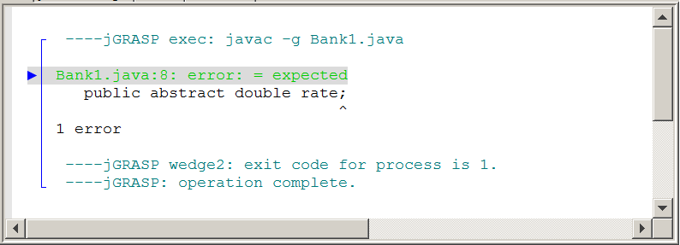

Figure 13.18
// Interface06
// This <Bank2> interface declares a data field properly.
public interface Bank2
{
public final double rate = 3.25;
public double getBalance();
public void makeDeposit(double amount);
public void makeWithdrawal(double amount);
}

The Bank3 class implements Bank2. In figure 13.19 you will notice that a getRate method is included. This method is possible, because the rate attribute is declared public. Always do a quick compile check to make sure everything is OK and ready to go to the next stage.

Figure 13.19
// Interface06
// This <Bank3> class implements the <Bank2> interface
// and also provides a <getRate> method.
public class Bank3 implements Bank2
{
private int account;
private double balance;
public Bank2(int a, double c)
{
account = a;
balance = c;
}
public double getRate()
{ return rate; }
public int getAccount()
{ return account; }
public double getBalance()
{ return balance; }
public void makeDeposit(double amount)
{ balance += amount; }
public void makeWithdrawal(double amount)
{ balance -= amount; }
}

Using Fields in an Abstract Interface
Fields may be used in an interface declaration.
All fields must have an initial value.
Field values are constant and cannot be changed.
The final keyword is optional. Final is implied.

This interface sequence concludes with a test of Bank03. Note in figure 13.20 that the rate field is accessed two ways. The second approach is similar to what you have seen with list.length in a static array, as well as Math.PI and Math.E in the Math class.

Figure 13.20
// Interface06
// This program tests the <Bank1> interface with a non-abstract
// data field and a <getRate> method in the <Bank2> class.
public class Runner06
{
public static void main (String[ ] args)
{
Bank3 tom = new Bank2(736829056,5000.0);
System.out.println("Tom's account: " + tom.getAccount());
System.out.println("Tom's balance: " + tom.getBalance());
System.out.println("Tom's rate: " + tom.getRate());
System.out.println("Tom's rate: " + tom.rate);
}
}

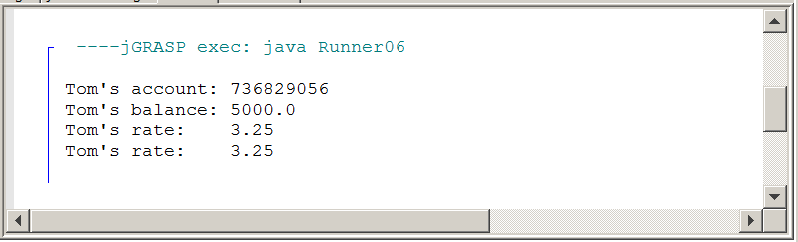

13.6 Abstract Classes

So far this chapter has worked with abstract classes and concrete implementing classes. In earlier chapters on inheritance you also learned about superclass and subclass. Well, we are not yet done with different type of classes. Now it is time to examine the abstract class. It is an interesting class that sits somewhere between the interface and the concrete class. This topic will be presented with a small HighSchool case study that will present a sequence of programs.
Abstract Class Case Study 01

The HighSchool Interface

High Schools do a tremendous amount of data processing and the arrival of the computer was quickly adopted by school administrators for attendance, gradebooks, student standings, course registration, etc. Imagine that we are members of a software engineering company. Our team is put in charge of creating a software package that handles all the data processing for a high school.

Figure 13.21, found in the AbstractClass01 folder, shows an interface, called HighSchool that includes all the processes that are necessary. In true interface spirit there is no concern right now how all this stuff will actually translate into program code. The methods in the interface are the requirements that the school administrators have specified.

Please note that we are totally unconcerned in this chapter if this casestudy is practical or if it is complete. We want to use the HighSchool casestudy to teach about abstract classes. We are not interested in creating a functional program. Later you will see that the implementing methods only have a println statement indicating what its functionality is. Look at the abstract methods below. This interface will be used in future case study stages. The interface will be present in every folder, but it will not be shown again, and again in each stage. Get a mental picture and know where to find this page if you need to return.

Figure 13.21
// AbstractClass01
// This is the <HighSchool> interface that will be used for
// the Chapter XIII "abstract class" Case Study .
public abstract interface HighSchool
{
public abstract void information();
public abstract void test();
public abstract void emergency();
public abstract void computeGPA();
public abstract void progress();
public abstract void attendance();
public abstract void dressCode();
public abstract void residence();
public abstract void register();
public abstract void orientation();
public abstract void fundRaising();
public abstract void socialEvents();
public abstract void parking();
}

Abstract Class Case Study 02

Implement the High School Interface

When you consider the methods of the HighSchool program, you can see that the same method will not be identical for different class levels, at least not every method. It is not possible to create a single concrete class and implement all the methods. A decision is made to create four classes that will each implement every one of the abstract methods. There will be one class for each grade level. One method will not handle four grades. For instance, take the parking method. 9th and 10th graders have no parking privileges at all. 11th graders have a parking lot just for 11th graders, but no assigned spaces. 12th graders have a closer parking lot and each 12th grader has its own numbered parking space.

Switch to the AbstractClass02 folder. The HighSchool interface is repeated. There are four concrete classes, one for each grade level that will each implement the interface according to its needs. Finally, the Test02 file will test the program. Figures 13.22, 13.23, 13.24 and 13.25 show the concrete class implementations.

Figure 13.22
// AbstractClass02
// This is the <Grade09> implementation of the <HighSchool> interface.
public class Grade09 implements HighSchool
{
public void information()
{ System.out.println("Process STUDENT information"); }
public void test()
{ System.out.println("Administer pre-enrollment STUDENT testing"); }
public void emergency()
{ System.out.println("Gather STUDENT emergency forms"); }
public void computeGPA()
{ System.out.println("Compute STUDENT GPA "); }
public void progress()
{ System.out.println("Mail STUDENT progress report"); }
public void attendance()
{ System.out.println("Take STUDENT attendance"); }
public void dressCode()
{ System.out.println("Pass out STUDENT dresscode policies"); }
public void residence()
{ System.out.println("Process STUDENT residence proof"); }
public void register()
{ System.out.println("Register 9TH GRADER"); }
public void orientation()
{ System.out.println("Organize 9TH GRADE orientation"); }
public void fundRaising()
{ System.out.println("Explain 9TH GRADE fund raising"); }
public void socialEvents()
{ System.out.println("Organize 9TH GRADE social events"); }
public void parking()
{ System.out.println("9TH GRADE students have no parking lot"); }
}

Figure 13.23
// AbstractClass02
// This is the <Grade10> implementation of the <HighSchool> interface.
public class Grade10 implements HighSchool
{
public void information()
{ System.out.println("Process STUDENT information"); }
public void test()
{ System.out.println("Administer pre-enrollment STUDENT testing"); }
public void emergency()
{ System.out.println("Gather STUDENT emergency forms"); }
public void computeGPA()
{ System.out.println("Compute STUDENT GPA "); }
public void progress()
{ System.out.println("Mail STUDENT progress report"); }
public void attendance()
{ System.out.println("Take STUDENT attendance"); }
public void dressCode()
{ System.out.println("Pass out STUDENT dresscode policies"); }
public void residence()
{ System.out.println("Process STUDENT residence proof"); }
public void register()
{ System.out.println("Register 10TH GRADER"); }
public void orientation()
{ System.out.println("Organize 10TH GRADE orientation"); }
public void fundRaising()
{ System.out.println("Explain 10TH GRADE fund raising"); }
public void socialEvents()
{ System.out.println("Organize 10TH GRADE social events"); }
public void parking()
{ System.out.println("10TH GRADE students have no parking lot"); }
}

Figure 13.24
// AbstractClass02
// This is the <Grade11> implementation of the <HighSchool> interface.
public class Grade11 implements HighSchool
{
public void information()
{ System.out.println("Process STUDENT information"); }
public void test()
{ System.out.println("Administer pre-enrollment STUDENT testing"); }
public void emergency()
{ System.out.println("Gather STUDENT emergency forms"); }
public void computeGPA()
{ System.out.println("Compute STUDENT GPA "); }
public void progress()
{ System.out.println("Mail STUDENT progress report"); }
public void attendance()
{ System.out.println("Take STUDENT attendance"); }
public void dressCode()
{ System.out.println("Pass out STUDENT dresscode policies"); }
public void residence()
{ System.out.println("Process STUDENT residence proof"); }
public void register()
{ System.out.println("Register11TH GRADER"); }
public void orientation()
{ System.out.println("Organize11TH GRADE orientation"); }
public void fundRaising()
{ System.out.println("Explain11TH GRADE fund raising"); }
public void socialEvents()
{ System.out.println("Organize11TH GRADE social events"); }
public void parking()
{ System.out.println("Distribute 11TH GRADE parking lot stickers"); }
}

Figure 13.25
// AbstractClass02
// This is the <Grade12> implementation of the <HighSchool> interface.
public class Grade12 implements HighSchool
{
public void information()
{ System.out.println("Process STUDENT information"); }
public void test()
{ System.out.println("Administer pre-enrollment STUDENT testing"); }
public void emergency()
{ System.out.println("Gather STUDENT emergency forms"); }
public void computeGPA()
{ System.out.println("Compute STUDENT GPA "); }
public void progress()
{ System.out.println("Mail STUDENT progress report"); }
public void attendance()
{ System.out.println("Take STUDENT attendance"); }
public void dressCode()
{ System.out.println("Pass out STUDENT dresscode policies"); }
public void residence()
{ System.out.println("Process STUDENT residence proof"); }
public void register()
{ System.out.println("Register 12TH GRADER"); }
public void orientation()
{ System.out.println("Organize 12TH GRADE orientation"); }
public void fundRaising()
{ System.out.println("Explain 12TH GRADE fund raising"); }
public void socialEvents()
{ System.out.println("Organize 12TH GRADE social events"); }
public void parking()
{ System.out.println("Distribute 12TH GRADE parking lot stickers"); }
}

What happens if these concrete classes get used in an actual program? Load program Test02.java, in figure 13.26, and observe the output. It is a long boring test. There is an object for each grade-level and then every method is tested for each one of the four grade-level objects. Figure 13.27 shows the program output. The program works correctly and reveals some interesting facts.

Figure 13.26
// AbstractClass02  // This program tests the abstract interface and  // its four implementing classes.  public class Test02  {  public static void main(String[] args)  {  HighSchool tom = new Grade09();  HighSchool sue = new Grade10();  HighSchool bob = new Grade11();  HighSchool ann = new Grade12();  System.out.println("TEST 9TH GRADE TOM");  tom.information();  tom.test();  tom.emergency();  tom.computeGPA();  tom.progress();  tom.attendance();  tom.dressCode();  tom.residence();  tom.register();  tom.orientation();  tom.fundRaising();  tom.socialEvents();  tom.parking();  System.out.println();  System.out.println("TEST 10TH GRADE SUE");  sue.information();  sue.test();  sue.emergency();  sue.computeGPA();  sue.progress();  sue.attendance();  sue.dressCode();  sue.residence();  sue.register();  sue.orientation();  sue.fundRaising();  sue.socialEvents();  sue.parking();  System.out.println(); | System.out.println("TEST 11TH GRADE BOB");  bob.information();  bob.test();  bob.emergency();  bob.computeGPA();  bob.progress();  bob.attendance();  bob.dressCode();  bob.residence();  bob.register();  bob.orientation();  bob.fundRaising();  bob.socialEvents();  bob.parking();  System.out.println();  System.out.println("TEST 12TH GRADE ANN");  ann.information();  ann.test();  ann.emergency();  ann.computeGPA();  ann.progress();  ann.attendance();  ann.dressCode();  ann.residence();  ann.register();  ann.orientation();  ann.fundRaising();  ann.socialEvents();  ann.parking();  System.out.println();  }  }

Figure 13.27
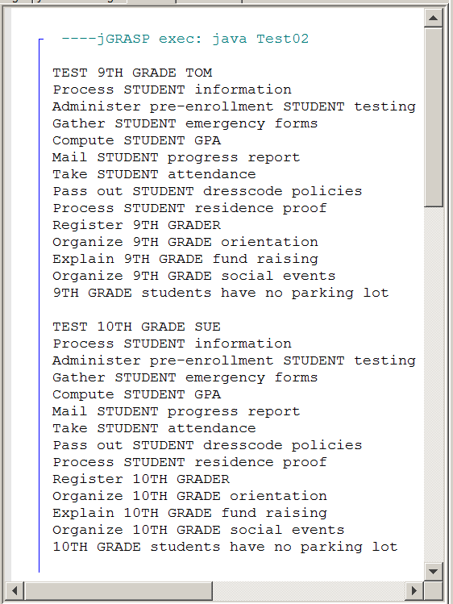 | 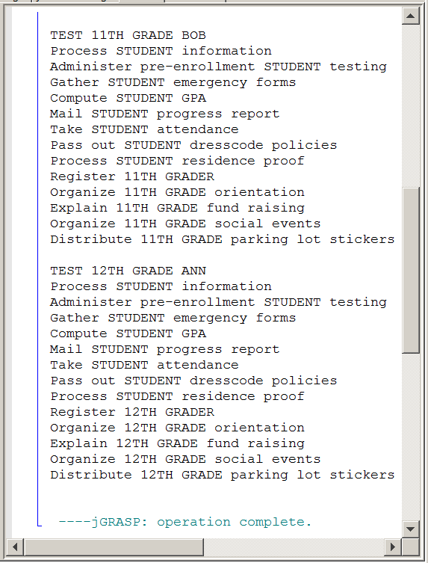

You see the four concrete classes, each implementing the High School interface. You see the output of this program. The Java code of the methods and the program output looks pretty much the same, except for some indication that this is for 9th, 10th, 11th or 12th grade students. Or was it? Not all output follows the same pattern. Not all methods behave in the same manner. Let's investigate what is going on.

In figure 13.28 the headings of the four grade level classes are shown with the implementation of the first method. The class headings implement the same interface, but each class has a different name. This is followed by the completed information method. Each new student arrives at the high school and then provides information about address, birth date, previous school, parents, etc.

Note that there is no difference in these methods. The process is the same for every level. If you only look at the method code or only look at the output of the method, it is not possible to detect the grade-level of the object calling the method.

Figure 13.28
public class Grade09 implements HighSchool
{
public void information()
{ System.out.println("Process STUDENT information"); }
..............................................................................................

public class Grade10 implements HighSchool
{
public void information()
{ System.out.println("Process STUDENT information"); }
..............................................................................................

public class Grade11 implements HighSchool
{
public void information()
{ System.out.println("Process STUDENT information"); }
.............................................................................................

public class Grade12 implements HighSchool
{
public void information()
{ System.out.println("Process STUDENT information"); }
..............................................................................................

Now look at another example in figure 13.29. Once again there are four class headings, which are the same as before. Now you also see the end of each class with the parking methods implemented. The story changes. This is not the behavior of the information method of the previous example.

Figure 13.29
public class Grade09 implements HighSchool
{
................................................................................................
public void parking()
{ System.out.println("9TH GRADE students have no parking lot"); }
}

public class Grade10 implements HighSchool
{
................................................................................................
public void parking()
{ System.out.println("10TH GRADE students have no parking lot"); }
}
public class Grade11 implements HighSchool
{
................................................................................................
public void parking()
{ System.out.println("Distribute 11TH GRADE parking lot stickers"); }
}
public class Grade12 implements HighSchool
{
..............................................................................................
public void parking()
{ System.out.println("Distribute 12TH GRADE parking lot stickers"); }
}

In figure 13.28, the highlighted word was STUDENT inside each information method. You will note that there is a group of methods and each one states that something is happening to STUDENT. There is also a second set of methods and these methods are no longer identical. Now in place of STUDENT it indicates 9TH GRADE, 10TH GRADE, 11TH GRADE or 12TH GRADE.

This is a very significant discovery. So just how many methods are there which are identical for every grade-level and how many are grade-specific? Figure 13.30 shows all the HighSchool methods in two cells, separating the identical ones from the different methods.

Figure 13.30
public void information()
{ System.out.println("Process STUDENT information"); }
public void test()
{ System.out.println("Administer pre-enrollment STUDENT testing"); }
public void emergency()
{ System.out.println("Gather STUDENT emergency forms"); }
public void computeGPA()
{ System.out.println("Compute STUDENT GPA "); }
public void progress()
{ System.out.println("Mail STUDENT progress report"); }
public void attendance()
{ System.out.println("Take STUDENT attendance"); }
public void dressCode()
{ System.out.println("Pass out STUDENT dresscode policies"); }
public void residence()
{ System.out.println("Process STUDENT residence proof"); }
public void register()
{ System.out.println("Register 12TH GRADER"); }
public void orientation()
{ System.out.println("Organize 12TH GRADE orientation"); }
public void fundRaising()
{ System.out.println("Explain 12TH GRADE fund raising"); }
public void socialEvents()
{ System.out.println("Organize 12TH GRADE social events"); }
public void parking()
{ System.out.println("Distribute 12TH GRADE parking lot stickers"); }

7 methods say STUDENT and 5 methods say 12TH GRADE. Since there were 4 implementations of HighSchool that means there were 28 methods of which 21 were repetitions of totally identical, existing methods.

It is true that in this demonstration the methods were simple one-liners that displayed its purpose. In a real program these methods can be quite substantial and the number of common methods can also be quite a bit larger.
Is there a point to this lesson on redundancy and what is the connection with abstract classes, the topic of this chapter segment? Well consider that all methods in an interface must be abstract. Also consider that all methods in a concrete class must be concrete and all the methods must be implemented. And surprise, the methods in an abstract class have a choice and can be abstract or concrete.

Interface, Abstract Class & Concrete Class
All methods of an interface must be abstract.

All methods in a concrete class must be concrete and all the methods of the interface must be implemented.

Methods in an abstract class may be abstract or concrete.

The abstract class, with its ability to be part abstract and part concrete has the ability to provide a perfect bridge between the interface and the multiple, concrete classes. This has some interesting implications for our HighSchool program, shown in the next section .

13.7 Abstract Class as a Bridge Class

Interfaces, abstract classes, concrete classes along with inheritance and implementation are explained in one chapter. Some teachers and possibly some students who do well teaching themselves, may say well what about polymorphism? Good question. I never could explain everything all at once and I have listened to enthusiastic presenters who try to be so accurate and so complete and totally drown their audience in a flood of information. Please have patience, there is more to be explained later.

We had a situation with one High School interface containing 12 methods. This interface was implemented by 4 classes for a total of 48 methods. We saw evidence that 7 of the methods are identical for each of the 4 classes. It creates a redundant bunch of methods. Take a look at figure 13.31. Does it make sense?

Figure 13.31
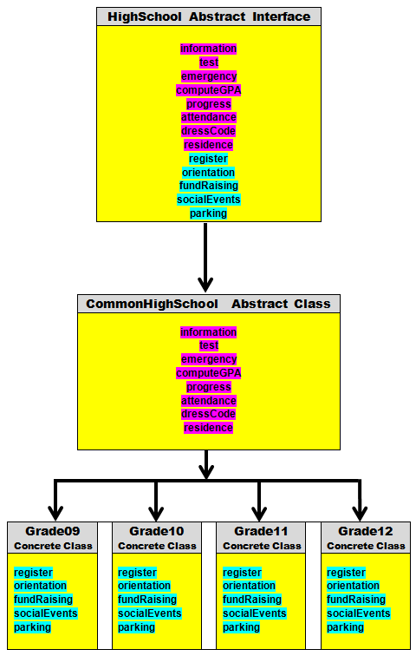

Abstract Class Case Study 03, 04

Using an Abstract Class of Common Methods

The abstract class, with its unique ability to implement some interface methods, but not all of them, has a great solution. After the abstract methods for the interface are decided, gather up all the methods that are known to be identical for any implementing, concrete class. Then place these common methods in an abstract class. In our example the abstract class is CommonHighSchool.

In the figure 13.31 diagram, you see 7 methods - all the ones that display STUDENT - placed inside the CommonHighSchool implementing abstract class. Now you can continue and write the four concrete classes, but it is only necessary to write the 5 methods that are different for each grade-level. Check the AbstractClass03 folder. The HighSchool interface you know. It has not changed. Load the CommonHighSchool.java file, shown in figure 13.32.

Figure 13.32
// AbstractClass03
// This is the <CommonHighSchool> abstract class implementation
// of the <HighSchool> interface. All methods that are implemented
// individually by grade are left abstract.
public abstract class CommonHighSchool implements HighSchool
{
public void information()
{ System.out.println("Process STUDENT information"); }
public void test()
{ System.out.println("Administer pre-enrollment STUDENT testing"); }
public void emergency()
{ System.out.println("Gather STUDENT emergency forms"); }
public void computeGPA()
{ System.out.println("Compute STUDENT GPA "); }
public void progress()
{ System.out.println("Mail STUDENT progress report"); }
public void attendance()
{ System.out.println("Take STUDENT attendance"); }
public void dressCode()
{ System.out.println("Pass out STUDENT dresscode policies"); }
public void residence()
{ System.out.println("Process STUDENT residence proof"); }
public abstract void register();
public abstract void orientation();
public abstract void fundRaising();
public abstract void socialEvents();
public abstract void parking();
}

This time there will not be the need to show each one of the four concrete classes. Only Grade09.java, in figure 13.33, will be shown. You can see the other three classes in the AbstractClass03 folder.

Figure 13.33
// AbstractClass03
// This is the <Grade09> subclass of <CommonHighSchool>.
public class Grade09 extends CommonHighSchool
{
public void register()
{ System.out.println("Register 9TH GRADER"); }
public void orientation()
{ System.out.println("Organize 9TH GRADE orientation"); }
public void fundRaising()
{ System.out.println("Explain 9TH GRADE fund raising"); }
public void socialEvents()
{ System.out.println("Organize 9TH GRADE social events"); }
public void parking()
{ System.out.println("9TH GRADE students have no parking lot"); }
}

This concrete class is much smaller. Only 5 methods are needed. Note that the Grade09 class extends the CommonSchool class. This is inheritance, not implementation. It is true that 5 methods are implemented, but it is also true that the Grade09 class will use the 7 methods already implemented in its superclass.

Now it is time to test this approach with a concrete class. Test03.java is identical to Test02.java and the output is identical. As a matter of fact it will not be possible to tell by the output whether an abstract class is used or not.
The next casestudy AbstractClass04 stage does not bring much new excitement. It is mostly a repeat of the third stage. There is a point that needs to be made. Look at the abstract class for stage 4, in figure 13.34. The file is smaller. You won't see the 5 abstract methods that were not implemented. They did show up in the 3rd stage. Like many other required matters in Java, if it is shown, if it cannot be done any other way, then it does not need to be explicitly shown, like the abstract word in an interface. Java knows that the non-implemented abstract methods in an abstract class will need to be finished later, but it is not required to list those methods again in the abstract class. You can check the four implementing classes. They are 100% identical to the same classes in stage 03.

Figure 13.34
// AbstractClass04
// This is the <CommonHighSchoolr> abstract class implementation
// of the <HighSchool> interface. All methods that are not
// implemented are not shown, as they were in Stage #3.
public abstract class HighSchoolAdapter implements HighSchool
{
public void information()
{ System.out.println("Process STUDENT information"); }
public void test()
{ System.out.println("Administer pre-enrollment STUDENT testing"); }
public void emergency()
{ System.out.println("Gather STUDENT emergency forms"); }
public void computeGPA()
{ System.out.println("Compute STUDENT GPA "); }
public void progress()
{ System.out.println("Mail STUDENT progress report"); }
public void attendance()
{ System.out.println("Take STUDENT attendance"); }
public void dressCode()
{ System.out.println("Pass out STUDENT dresscode policies"); }
public void residence()
{ System.out.println("Process STUDENT residence proof"); }
}

13.8 Abstract Classes as an Adapter

Abstract Class Case Study 05

There is another, somewhat similar way to use an abstract class. Once again it is in a position between an interface and concrete classes. It is in the form of an adapter class. adapter is not a Java reserved word like abstract, it has a special meaning in computer programming. Go to the AbstractClass05 folder and load the HighSchoolAdapter class, shown in figure 13.35. This is a peculiar looking class, to say the least. It looks more like an interface than anything else. None of the methods are implemented, or are they? The truth is that every method is implemented. Not exactly in a practical way, but with an empty body.

Figure 13.35
// AbstractClass05
// This is an abstract class with all methods implemented,
// but none of them - intentionally - in a functional manner.
public abstract class HighSchoolAdapter implements HighSchool
{
public void information() { }
public void test() { }
public void emergency() { }
public void computeGPA() { }
public void progress() { }
public void attendance() { }
public void dressCode() { }
public void residence() { }
public void register() { }
public void orientation() { }
public void fundRaising() { }
public void socialEvents() { }
public void parking() { }
}

Can there be any need or justification for a class where every method has only a set of empty braces for execution? It may seem very odd, but yes there is some practical value.

Consider a situation where we have the HighSchool interface. We are not using any abstract class and go straight to a concrete class. At this point all that is required is the use of the information method. Why only one method? Don't ask. This is hypothetical. Now check out the Grade09A class, in figure 13.36. It shows what such a class will look like.
Figure 13.36
// AbstractClass05
// This is the <Grade09> implementation of the <HighSchool> interface.
// None of the other methods have to be implemented anymore.
public class Grade09A implements HighSchool
{
public void information()
{
System.out.println("Process 9TH GRADE information");
}
public void test() { }
public void emergency() { }
public void computeGPA() { }
public void progress() { }
public void attendance() { }
public void dressCode() { }
public void residence() { }
public void register() { }
public void orientation() { }
public void fundRaising() { }
public void socialEvents() { }
public void parking() { }
}

Remember the interface rule. You must implement every method of an interface in a concrete. You cannot pick and choose. If there are 12 abstract methods, as the HighSchool interface, and you only wish to implement one method, the rules do not change. In such a case you write one method, as you see done here, and then you create 11 dummy methods that do nothing. Now look at Grade09B, in figure 13.37. This class looks much smaller. All these empty, do nothing, methods are gone. There is one significant difference. The Grade09B class extends the HighSchoolAdapter class.

Figure 13.37
// AbstractClass05
// This is the <Grade09B> extension of the <HighSchoolAdapter> abstract class.
// None of the other methods have to be implemented anymore.
public class Grade09B extends HighSchoolAdapter
{
public void information()
{
System.out.println("Process 9TH GRADE information");
}
}

This brings curiosity about what is going on in the HighSchoolAdapter class? Load the abstract class in figure 13.38 and see. Every method is implemented as an empty method. The Java rules states that every interface method must be implemented. It does not say by how much. This rule is now satisfied. So when Grade09B, extends - not implements - HighSchoolAdapter it is no longer an issue of implements. It is now inheritance and you are free to re-define just one method is you so desire. Figure 13.39 shows the Test05 program and output.

Figure 13.38
// AbstractClass05
// This is an abstract class with all methods implemented,
// but none of them - intentionally - in a functional manner.
public abstract class HighSchoolAdapter implements HighSchool
{
public void information() { }
public void test() { }
public void emergency() { }
public void computeGPA() { }
public void progress() { }
public void attendance() { }
public void dressCode() { }
public void residence() { }
public void register() { }
public void orientation() { }
public void fundRaising() { }
public void socialEvents() { }
public void parking() { }
}

Figure 13.39
// AbstractClass05
// This program tests the HighSchoolAdapter Class.
public class Test05
{
public static void main(String[ ] args)
{
HighSchool tom = new Grade09B();
tom.information();
}
}

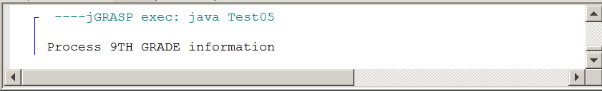
13.9 Constructors in an Abstract Class

Abstract Class Case Study 06

The last section showed the practical use of an abstract class as a stage between an interface and a concrete class. The abstract class was used to implement the common methods that all concrete classes would implement the same way. Now switch to another issue. How about using a constructor in an abstract class? Is that possible? The CommonHighSchool class in figure 13.40 adds a constructor with a println statement to check if the constructor is used.

Figure 13.40
// AbstractClass06
// This abstract class has a constructor.
// This stage tests to see if a constructor in an abstract class
// can be called and used by a subclass.
public abstract class CommonHighSchool implements HighSchool
{
public CommonHighSchool()
{
System.out.println("CommonHighSchool Constructor");
}
public void information()
{ System.out.println("Process STUDENT information"); }
public void test()
{ System.out.println("Administer pre-enrollment STUDENT testing"); }
public void emergency()
{ System.out.println("Gather STUDENT emergency forms"); }
public void computeGPA()
{ System.out.println("Compute STUDENT GPA "); }
public void progress()
{ System.out.println("Mail STUDENT progress report"); }
public void attendance()
{ System.out.println("Take STUDENT attendance"); }
public void dressCode()
{ System.out.println("Pass out STUDENT dresscode policies"); }
public void residence()
{ System.out.println("Process STUDENT residence proof"); }
}

We do know that the Grade09 class, in figure 13.41, can use a constructor. It is a concrete class, but can it call the constructor of its superclass? That is precisely what is tested here. Figure 13.42 shows a very small Test06 program. There is no concern in calling any of the HighSchool methods. The only concern is with testing the constructors in CommonHighSchool and Grade09.
Figure 13.41
// AbstractClass06
// This program tests if a subclass can call and use
// a constructor in an abstract class.
public class Grade09 extends CommonHighSchool
{
public Grade09()
{
super();
System.out.println("Grade09 Constructor");
}
public void register()
{ System.out.println("Register 9TH GRADER"); }
public void orientation()
{ System.out.println("Organize 9TH GRADE orientation"); }
public void fundRaising()
{ System.out.println("Explain 9TH GRADE fund raising"); }
public void socialEvents()
{ System.out.println("Organize 9TH GRADE social events"); }
public void parking()
{ System.out.println("9TH GRADE students have no parking lot"); }
}

Figure 13.42
// AbstractClass06
// This program tests if you can call and use
// a constructor in an abstract class.
public class Test06
{
public static void main(String[ ] args)
{
Grade09 test = new Grade09();
}
}

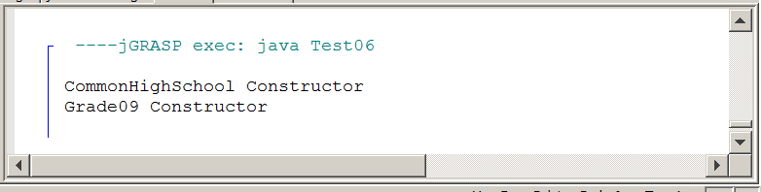
The program output proves that both constructors are called. It is possible to place a constructor in an abstract class and that constructor can be called by its subclasses. Our testing is not yet finished. We have shown that a constructor can be called in an abstract Class. Can we actually use the new operator and not only call the constructor, but also instantiate an object of the abstract class? Switch to folder AbstractClass07 to check that question.

The files in AbstractClass07 are pretty much the same as the previous stage. The difference is that the concrete class Grade09 is missing. The only difference in code is the testing program, shown in figure 13.43. You see that it states new CommonHighSchool(); and not new Grade09();

Figure 13.43
// AbstractClass07
// This program tests if you can
// instantiate an abstract class.
public class Test07
{
public static void main(String[ ] args)
{
CommonHighSchool test = new CommonHighSchool();
}
}

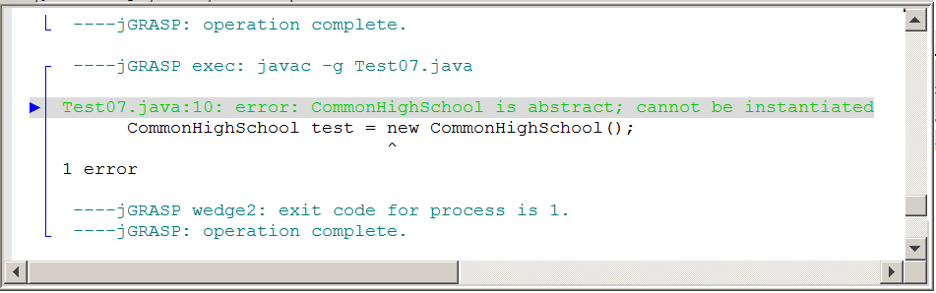

This program output makes is very clear: HighSchoolAdapter is abstract; cannot be instantiated. It was a good try and it is precisely these types of tests that help a student understand the details of a programming language. It is difficult to pack every permutation of a language in a textbook. You want to learn? You want to see what is going on? Alter the code. Create some special situations. Check it out. Even better . . . what you discover on your own, sticks. You won't forget.
13.10 Behind the Generics Curtain

The dynamics array chapter with the ArrayList class introduced a new concept, called generics. It is a concept that is not unique to the ArrayList class. With generics you are able to declare a data structure to contain objects of a specific class. The type of syntax that indicates use of generics is shown in figure 13.44.

Figure 13.44
// Generics01
// This is an example of using <ArrayList> with “generics”.
import java.util.ArrayList;
public class GenericsDemo
{
public static void main (String[ ] args)
{
ArrayList<String> names = new ArrayList<String>();
ArrayList<Person> people = new ArrayList<Person>();
}
}
class Person
{
private String name;
private int age;
public Person(String n, int a)
{
name = n;
age = a;
}
}

Two generic objects are declared in this example. Between the angle brackets it indicates that names will a <String> array and people will be a <Person> array. The syntax is not complicated and it simplifies working with objects that can now be attached to a specific data type. That word specific brings something to mind. The program examples work with String and Person objects. That is specific and when we use these specific data types, we called it generics. That seems really weird and counter-intuitive.

The objective for the remainder of this chapter is to give you a better understanding about generic classes, how they are declared and why the name generics really is appropriate.
The Course Description for AP Computer Science, distributed by the College Board includes an appendix of standard Java libraries that are part of the Java Subset. This appendix is available during the AP Exam. Figure 13.45A shows a portion of this appendix that concentrates on the List interface and the ArrayList class. Perhaps you have seen this before or you now see it for the first time. You see the familiar angle brackets that are used with generics and you also see a bunch of E letters floating around, some inside angle brackets and others not. In figure 13.45B the exact same List interface is placed in a Java file. Explaining what is going on will take a few steps. We will return to this List interface, but first we need a detour.

Figure 13.45A

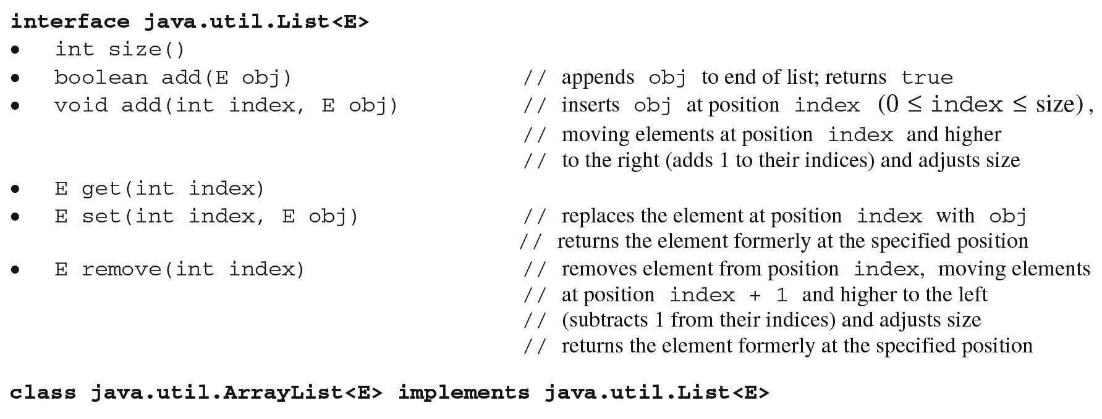

Figure 13.45B
// Generics01
// This is how the <List> interface appears on the College Board
interface List<E>
{
public int Size();
public boolean add(E obj);
public void add(int index, E obj);
public E get(int index);
public E set(int index, E obj);
public E remove(int index);
}

Generics02 in figure 13.45 shows an interface that is similar to the List interface. The methods have the same names, but there are no E letters running around and this interface concentrates on processing int data only.

Figure 13.46
// Generics02
// This <IntList> interface strictly specializes with methods to process <int> variables only.
public interface IntList
{
public int size();
public void add(int nbr);
public void add(int index, int nbr);
public int get(int index);
public void set(int index, int nbr);
public int remove(int index);
}

The IntArray class implements each one of the abstract methods and creates a fully functional class for processing integers in an array. Figure 13.47 shows the entire class with all it implemented methods.

Figure 13.47
// Generics02
// The <IntArray> "concrete" class implements the <IntList> "abstract" interface.
public class IntArray implements IntList
{
private int[ ] array;
private int size;
public IntArray()
{
array = new int[10000];
size = 0;
}
public int size()
{
return size;
}
public void add(int nbr)
{
array[size] = nbr;
size++;
}
public void add(int index, int nbr)
{
size++;
for (int k = size-1; k > index; k--)
array[k] = array[k-1];
array[index] = nbr;
}
public int get(int index)
{
return array[index];
}
public void set(int index, int nbr)
{
array[index] = nbr;
}
public int remove(int index)
{
int temp = array[index];
for (int k = index; k < size-1; k++)
array[k] = array[k+1];
size--;
return temp;
}
public String toString()
{
String temp = "[";
for (int k = 0; k < size-1; k++)
temp = temp + array[k] + ", ";
temp = temp + array[size-1] + "]" + "\n";
return temp;
}
}

Generics02 concludes with testing the IntArray class using Runner02.java, in figure 13.48. You will see that every method is used in a rather thorough test. This is a good example of doing more than reading the words. Load the files, watch the execution and then alter values in the runner program to observe the results. You cannot swim without getting wet in a pool and programming does not make much sense unless you see how a program behaves in different circumstances. Computer Science is not a memory subject.
Figure 13.48
// Generics02
// This class tests the <IntArray> implementation of the <IntList> interface.
public class Runner02
{
public static void main (String[ ] args)
{
IntArray numbers = new IntArray();
for (int k = 0; k < 10; k++)
numbers.add(k + 100);
System.out.println(numbers);
numbers.add(10,999);
numbers.add(0,999);
System.out.println(numbers);
for (int k = 0; k < numbers.size(); k++)
System.out.print(numbers.get(k) + " ");
System.out.println("\n");
numbers.set(3,555);
numbers.set(6,555);
System.out.println(numbers);
numbers.remove(3);
numbers.remove(6);
System.out.println(numbers);
}
}

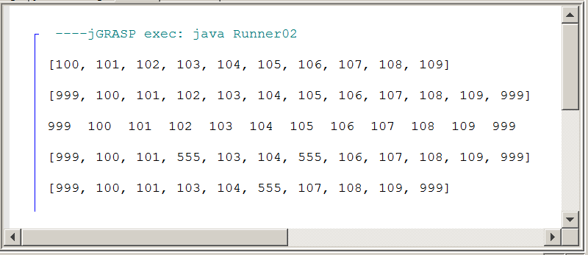

You just observed the files used for an integer array class. Now we continue and look at a class that can handle any kind of class. This will not be a class implementing an interface.

What is different, is the fact that we want to declare our very own generic class. Since the class works with any object, its class name will be ObjArray. Go to the Generics03A folder to load the files. Figure 13.49 shows the class. look at the class heading first, which is . . .

public class ObjArray<E>

There is the E again. Right now realize that E is a variable. It can be Aardvark as far as Java is concerned. E is a good choice and means Element. As the data type of the individual data structure element. It is not really the same, but you can almost consider the class heading to be like a method heading with a parameter. E is the parameter of the class. Now E does not have a value, it has a class. Look at the remainder of the class. There are many Es and every one of them will be substituted with the class identifier used when a new object is declared.

The earlier integer array declared many methods and these methods used int as parameters and used int as return types. You see the same with the ObjArray class, except where there used to be int, there is now E.

Figure 13.49
// Generics03A
// This <ObjArray> class is declared as a "generic" class.
// "Class Parameter" <E> takes on the value of the data type
// when a new <ObjArray> object is instantiated.
public class ObjArray<E>
{
private Object[ ] array;
private int size;
public ObjArray()
{
array = new Object[10000];
size = 0;
}
public int size()
{
return size;
}
public void add(E obj)
{
array[size] = obj;
size++;
}
public void add(int index, E obj)
{
size++;
for (int k = size-1; k > index; k--)
array[k] = array[k-1];
array[index] = obj;
}
public E get(int index)
{
return (E) array[index];
}
public void set(int index, E obj)
{
array[index] = obj;
}
public E remove(int index)
{
E temp = (E) array[index];
for (int k = index; k < size-1; k++)
array[k] = array[k+1];
size--;
return (E) temp;
}
public String toString()
{
String temp = "[";
for (int k = 0; k < size-1; k++)
temp = temp + array[k] + ", ";
temp = temp + array[size-1] + "]" + "\n";
return temp;
}
}

The Runner03 class tests every method in the ObjArray class. A more thorough tests will check the array with multiple data types, not only String. This is precisely what you can do with the files in the Generics03A folder. The folder is called A, because it is followed by another folder with practically identical files that will be called Generics03B.

Figure 13.50
// Generics03
// The <Runner03> class tests the "generic" <ObjArray> class.
public class Runner03
{
public static void main (String[ ] args)
{
ObjArray<String> names = new ObjArray<String>();
names.add("Isolde");
names.add("John");
names.add("Greg");
names.add("Maria");
names.add("Heidi");
System.out.println(names);
names.add(5,"Braxi");
names.add(0,"Marie");
System.out.println(names);
for (int k = 0; k < names.size(); k++)
System.out.print(names.get(k) + " ");
System.out.println("\n");
names.set(3,"Aardvark");
names.set(4,"Aardvark");
System.out.println(names);
names.remove(3);
names.remove(4);
System.out.println(names);
}
}

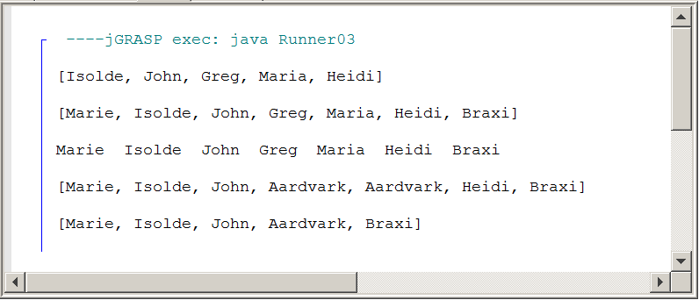
Now switch to the Generics03B folder. Load the ObjArray class, in figure 13.51 You will see the same methods as before. They have the same logic. The only difference is that the generic variable E is replaced with Aardvark. The Runner03 class is 100% the same and will not be shown again. Do load the runner class and determine that Java is quite happy. This is really about learning the difference between requirement and convention. There are reserved words like public, private static, void, etc. You cannot wake up one day and decide to use personal in place of private. Then there are conventions. Java has conventions to indent control structures. Different people use different indentation styles. because it is not required. Using E for Element or T for Type with generics is a rather strong convention. You will get some interesting comments from people if you use Aardvark.

Figure 13.51
// Generics03B
// This <ObjArray> class is declared as a "generic" class.
// The is almost identical to the Generics03A file.
// All the methods do the same process.
// The only difference is that <E> is now <Aardvark>.
public class ObjArray<Aardvark>
{
private Object[] array;
private int size;
public ObjArray()
{
array = new Object[10000];
size = 0;
}
public int size()
{
return size;
}
public void add(Aardvark obj)
{
array[size] = obj;
size++;
}
public void add(int index, Aardvark obj)
{
size++;
for (int k = size-1; k > index; k--)
array[k] = array[k-1];
array[index] = obj;
}
public Aardvark get(int index)
{
return (Aardvark) array[index];
}
public void set(int index, Aardvark obj)
{
array[index] = obj;
}
public Aardvark remove(int index)
{
Aardvark temp = (Aardvark) array[index];
for (int k = index; k < size-1; k++)
array[k] = array[k+1];
size--;
return (Aardvark) temp;
}
public String toString()
{
String temp = "[";
for (int k = 0; k < size-1; k++)
temp = temp + array[k] + ", ";
temp = temp + array[size-1] + "]" + "\n";
return temp;
}
}

The Logic Behind the “Generics” Name
With medicine we understand a "generic" drug to be one that does not have a brand-name requirement. Consider the following class heading:
public class Hospital<E>

It is not known what data type will be used by the Hospital class. In this case E may be objects of the Patient class or Person class. It does not matter. The class is designed to accept what is decided in an actual client program. Now look at the following instantiation:

Hospital<Person> h = new Hospital<Person>()

The confusion occurs when people look at the generic declaration, like the Hospital one. That is not generic. It is very specific. It states that the Hospital class will use Person objects. To understand the name generics you must look at the class declaration and there you see the very generic letter E, which indicates that a specific data type is not required.

13.11 The Generic List Interface

Now we return to the original List interface, shown again in figure 13.52. In this section you need to learn how the generic E travels from interface to concrete class. The interface below should now not be that confusing.

The interface heading, like a class heading dictates the data type for the everything within the interface or class. <E> follows the class or interface name and once the decision is made to use E, the same data type indicator is used in each one of the methods.

Figure 13.52
// Generics04
// This is how the <List> interface appears on the College Board
interface List<E>
{
public int size();
public boolean add(E obj);
public void add(int index, E obj);
public E get(int index);
public E set(int index, E obj);
public E remove(int index);
}

The ObjArray implements the generic List interface, in figure 13.53. You see that <E> is used next to the class name and it is also repeated next to the interface name. After the class heading is done the methods are the same. It matters little if this is an implementing class or a stand-alone class.

Figure 13.53
// Generics04
// The <ObjArray> class implements the <List> interface.
public class ObjArray<E> implements List<E>
{
private Object[] array;
private int size;
public ObjArray()
{
array = new Object[10000];
size = 0;
}
public int size() { return size; }
public boolean add(E obj)
{
array[size] = obj;
size++;
return true;
}
public void add(int index, E obj)
{
size++;
for (int k = size-1; k > index; k--)
array[k] = array[k-1];
array[index] = obj;
}
public E get(int index) { return (E) array[index]; }
public E set(int index, E obj)
{
E temp = (E) array[index];
array[index] = obj;
return temp;
}
public E remove(int index)
{
E temp = (E) array[index];
for (int k = index; k < size-1; k++)
array[k] = array[k+1];
size--;
return (E) temp;
}
public String toString()
{
String temp = "[";
for (int k = 0; k < size-1; k++)
temp = temp + array[k] + ", ";
temp = temp + array[size-1] + "]" + "\n";
return temp;
}
}

In figure 13.54 you see that the runner class tests the program in the same manner as a stand-alone class. The generics classes are not difficult to use. It is only at the instantiation of a new object that angle brackets and data types indicate how this class will be used. If you create your own generic class, it requires more care. The key concern is to make sure that the generic data type is used where needed. Sometimes people go too far. The index of an element is int not E.
Figure 13.54
// Generics04
// The <Runner04> class tests the "generic" <ObjArray> class.
public class Runner04
{
public static void main (String[ ] args)
{
ObjArray<String> names = new ObjArray<String>();
names.add("Isolde");
names.add("John");
names.add("Greg");
names.add("Maria");
names.add("Heidi");
System.out.println(names);
names.add(0,"Braxi");
names.add(6,"Marie");
System.out.println(names);
for (int k = 0; k < names.size(); k++)
System.out.print(names.get(k) + " ");
System.out.println("\n");
names.set(3,"Aardvark");
System.out.println(names.set(4,"Aardvark"));
System.out.println(names);
names.remove(3);
names.remove(4);
System.out.println(names);
}
}

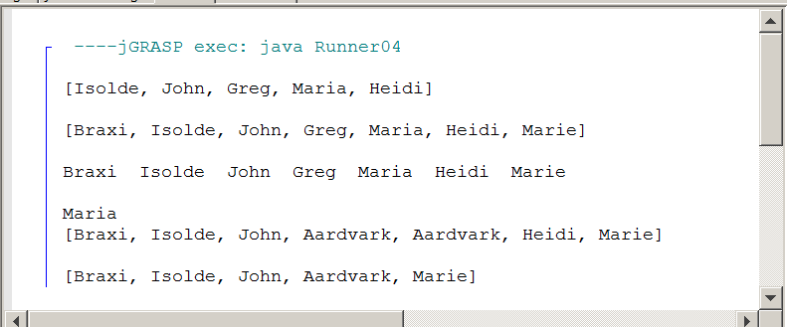

13.12 Generics and Subinterfaces

At the beginning of this chapter diagram in figure 13.55 was presented. It shows interfaces and classes, but it also indicates that there is something called a subinterface, located between the Collection interface and the four concrete classes, ArrayList, LinkedList, HashSet and TreeSet.

This brings up an interesting question. Every method in an interface is abstract, which should include every method of a subinterface. So what is the relationship between an interface and a subinterface?

Figure 13.55

Look at the diagram again. List is an ordered Collection and Set is an unordered Collection. Set classes will have requirements that are different from List classes. For instance, in a List class you want a get method, which return an element at a specified index. This method makes no sense in a Set class. The members in a set are not ordered. There is no index. However, it is important to know if some object is a member of a Set class. That is precisely the job of a contain method.

So we start at the top with a Collection interface and you find some abstract methods there that will be found in any class. We go down one level to two subinterfaces and there some methods are added. These methods are different for List and for Set. Go to the Generics05 folder and load the Collection05A file.

In figure 13.55 you see that the single file contains the CollectionA interface, the List subinterface and the concrete MyList class. Look at the Java syntax to establish the relationship. The subinterface is an interface and its methods are all abstract. Its job is not to implement, but to add additional abstract methods for its own branch, in this case the List classes.

The syntax that is used is the syntax of inheritance. List extends CollectionA and inside the subinterface is one additional abstract method get. Further down the concrete class MyList now has the job to implement the two abstract methods, add and isEmpty, declared in the Collection interface and then also implement the additional get method added in the List subinterface. Don't be concerned about the minimal, impractical method implementations. It is the relationship between the interface, subinterface and concrete class that matters here.

Figure 13.55
// Generics05A
// In this example <Collection> is an interface.
// <List> is a subinterface, which extends <Collection>.
// <MyList> implements <List> and by extension also <Collection>.
// This is not a practical example of using a subinterface.
public interface CollectionA
{
public boolean add(int nbr);
public boolean isEmpty();
}
interface List extends CollectionA
{
public int get(int index);
}
class MyList implements List
{
public boolean add (int nbr) { return true; }
public boolean isEmpty() { return true; }
public int get(int index) { return 0; }
}

This example was intentionally as simple as possible. Now switch your attention to the Collection05B file, shown in figure 13.56. This file is designed to resemble the earlier diagram. The methods shown are just a few examples and not the actual number of methods that are found in the Collection classes. Once again, our interest is in the design and the relationships, not the method details.

The file in figure 13.56 is meant to resemble the Collection diagram, but there are only two concrete classes. The main focus of this section is on the use of subinterfacfes. Note how each subinterface adds one new method, different from the other subinterface. At the level of very concrete classes you see that each class implements the original abstract methods found in the Collection interface and then continues to implement the additional method from its own subinterface.

Figure 13.56
// Generics05B
// In this example <Collection> is an interface.
// <List> is a subinterface, which extends <Collection>.
// <Set> is also a subinterface, which extends <Collection>.
// <MyList> implements <List> and by extension also <Collection>.
// <MySet> implements <Set> and by extension also <Collection>.
public interface CollectionB
{
public boolean add(int nbr);
public boolean isEmpty();
}
interface List extends CollectionB
{
public int get(int index);
}
interface Set extends CollectionB
{
public boolean contain(int nbr);
}
class MyList implements List
{
public boolean add (int nbr) { return true; }
public boolean isEmpty() { return true; }
public int get(int index) { return 0; }
}
class MySet implements Set
{
public boolean add (int nbr) { return true; }
public boolean isEmpty() { return true; }
public boolean contain(int nbr) { return true; }
}

Absent from the previous files was our new friend, generics. In Generics06 you will see a very similar file Generics05B used, but now the familiar Es are included. Does the logic of passing the generic data type identifier <E> down from interface to subinterface to concrete class make sense?

Figure 13.57
// Generics06
// The <int> interfaces and classes are now replaced by generics.
// All the methods are the same as in Generics05B, but now the
// a specific class can be used when instantiating a <MyList> or <MySet> object.
public interface Collection<E>
{
public void add(E obj);
public boolean isEmpty();
}
interface List<E> extends Collection<E>
{
public E get(int index);
}
interface Set<E> extends Collection<E>
{
public boolean contain(E obj);
}
class MyList<E> implements List<E>
{
public void add (E obj) { }
public boolean isEmpty() { return true; }
public E get(int index) { return null; }
}
class MySet<E> implements Set<E>
{
public void add (E obj) { }
public boolean isEmpty() { return true; }
public boolean contain(E obj) { return true; }
}

There have been many examples now of lovely Java code that showed syntax, but did not really execute any type of program output. This will change in the final stage of Generics07.
Switch to Generics07 and in the final stage we use proper one-class, one-file program design. There will be lots of separate files. Let start at the top and visit every one down to the runner class. The interface headings and the class headings will no longer be enlarged and accented. The relationship part was done earlier. Now we want practicality and have this code do something. The start, in figure 13.58, still won't do anything, because there are only abstract methods involved. At the Collection level there are only two methods. Do keep in mind that the real Collection interface has more methods, but that will add more confusion.

Figure 13.58
// Generics07
// The <Collection> interface starts with methods <add> and <isEmpty>.
public interface Collection<E>
{
public boolean add(E obj);
public boolean isEmpty();
}

Figure 13.59 and figure 13.60 continue with the List subinterface and the Set subinterface. At this level it is still abstract and looks no different from before.

Figure 13.59
// Generics07
// The <List> subinterface adds the <get> method to the
// <add> and <isEmpty> methods.
public interface List<E> extends Collection<E>
{
public E get(int index);
}

Figure 13.60
// Generics07
// The <Set> subinterface adds the <contain> method to the
// <add> and <isEmpty> methods.
public interface Set<E> extends Collection<E>
{
public boolean contain(E obj);
}

Finally, concrete class MyList, in figure 13.61, gets down to the business of implementing each one of the abstract methods. This class also has some attributes, a constructor and a toString method. In figure 13.62, the MySet concrete class is very similar to the MyList class. You'd expect a difference between the two concrete classes since one implements get and the other one implements contain. But look at the implementations of the two add methods. In the List classes there can be multiple identical members. In the set classes there cannot be any duplicate members. This must be checked at the add level.

Figure 13.61
// Generics07
// The <MyList> class implements the <List> subinterface
public class MyList<E> implements List<E>
{
private int size;
private Object[ ] objects;
public MyList(int n)
{
objects = new Object[n];
size = 0;
}
public boolean add (E obj)
{
objects[size] = obj;
size++;
return true;
}
public boolean isEmpty()
{
return size == 0;
}
public E get(int index)
{
return (E) objects[index];
}
public String toString()
{
String temp = "";
for (int k = 0; k < size; k++)
temp = temp + objects[k] + "\n";
return temp;
}
}

Figure 13.62
// Generics07
// The <MySet> class implements the <Set> subinterface
class MySet<E> implements Set<E>
{
private int size;
private Object[] objects;
public MySet(int n)
{
objects = new Object[n];
size = 0;
}
public boolean add (E obj)
{
if (contain(obj))
{
return false;
}
else
{
objects[size] = obj;
size++;
return true;
}
}
public boolean isEmpty() { return size == 0; }
public boolean contain(E obj)
{
boolean noMatch = true;
int index = 0;
while (index < size && noMatch)
{
if (objects[index].equals(obj))
noMatch = false;
else
index++;
}
return noMatch == false;
}
public String toString()
{
String temp = "";
for (int k = 0; k < size; k++)
temp = temp + objects[k] + "\n";
return temp;
}
}

The two add methods will be shown side-by-side. There is an important point that needs to be made here. Methods at the interface level are abstract and this is one reason why. Down some levels implementation is not the same. You will see this in figure 13.63 where MyList and MySet use different code.

The first add method for any List concrete class is unconcerned with duplicate elements. The new object is added to the objects array and the array size is increased by 1. And . . .? there is a return true; statement. You may not have noticed it, but back at the Collection level, the abstract add method is shown as a return method and the return type is boolean.

Now switch your attention to the second add method. This method starts to see if the parameter obj is already contained in the Set object. Remember, no duplicate members in a Set object. In the event the contain method call indicates that the member is already present, the parameter object is not added and the method returns false. This makes sense when you work with sets. Addition is not always possible and that needs to be communicated.

Figure 13.63
MyList add method | MySet add method
public boolean add (E obj)  {  objects[size] = obj;  size++;  return true;  } | public boolean add (E obj)  {  if (contain(obj))  {  return false;  }  else  {  objects[size] = obj;  size++;  return true;  }  }

The difference between the add method is also shown by the final testing program, in figure 13.64. Two objects are instantiated, one for each type of concrete class. Then objects are added with an intentional attempt to add a second object. The toString method assists to help display the members. The output display in figure 13.65 proves that sets do not allow duplicate members.

Figure 13.64
// Generics07
// <Runner07> the difference between the <MyList> and <MySet>
// implementations. Note how the <add> method is not the same
// for a list or a set. A set does not contain duplicate objects.
public class Runner07
{
public static void main(String[ ] args)
{
MyList<String> cats = new MyList<String>(1000);
cats.add("Tiger");
cats.add("Lion");
cats.add("Leopard");
cats.add("Cheetah");
cats.add("Panther");
cats.add("Leopard");
System.out.println(cats);
MySet<String> birds = new MySet<String>(1000);
birds.add("Eagle");
birds.add("Falcon");
birds.add("Owl");
birds.add("Pigeon");
birds.add("Cardinal");
birds.add("Falcon");
System.out.println(birds);
}
}

Figure 13.65
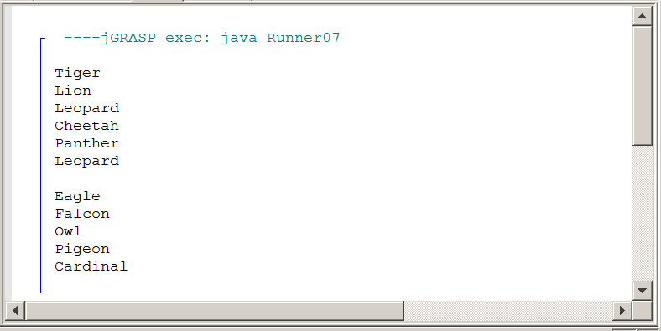

13.11 Summary

An interface contains a group of methods signatures that will be implemented in another class. Every method in an interface is abstract and any class implementing an interface must implement every method of the interface. A concrete class that implements an interface may include additional methods that were not original members of the interface.

It is possible to contain a data field in an interface, but this data field is final and must have an assigned value. The final keyword and abstract keyword is optional in an interface and its use is implied.

Java has a hybrid type of class, called an abstract class. Abstract classes can contain abstract methods and concrete methods. A good use of an abstract class is to be a bridge between an interface and an concrete class. The abstract class can implement the methods that all concrete clases will share.
Abstract classes are also used as adapter classes. In an adapter class all the methods of the interface are implemted with empty body methods. It is then possible to create a concrete class, which extends the adapter class and only the methods that are used need to be implemented.

Generic classes allow declaring the data type of class members at instantiation. This data type is placed between angled brackets, like <String>. Once an object is instantiated it is linked to a specific data type, Java will not allow any other date type to be used in the data structure.

Java has a very general data strucrture, called Colletion, which is a generic container to hold members. Collection is extended by two subinterfaces List and Set. For the AP Exam only the List interface and the implementing ArrayList is tested. The ArrayList class is generic.

The generic data type starts in the Collection interface and is usually a variable like E for Element or T for Type. The generic data type then continues to the subinterface List and concludes in the concrete ArrayList class.

Java Interface
A Java interface provides a group of method signatures that will be available for any client of a class that implements the interface. Implementation details of the interface methods are neither required nor possible at the interface level.

Collection
A collection is a group of objects.

Lists
A list is a linear collection that allows access to any element in the list. A list may have duplicate elements.

Sets
A set is an unordered collection without any duplicate elements.

Implementation Rule
A class, which implements an interface, must implement every method declared in the interface, unless it is an abstract class.

Using Fields in an Abstract Interface
Fields may be used in an interface declaration.
All fields must have an initial value.
Field values are constant and cannot be changed.
The final keyword is optional.

Abstract Interfaces and Abstract Classes
All methods of an interface must be abstract.
Methods in an abstract class may be abstract or concrete.
Abstract classes can be used to implement the common methods for multiple subclasses.

